Test Design

The test plan for the Parabank website consisted of 11 HTTP request scripts that were obtained and chosen from an HTTP(S) Test Script recorder session. These requests include:
- Accessing the Homepage in /index.htm
- Login with the username chaelg11! and password abc1234
- Accessing account overview
- Redirected to overview.htm
- Clicking account number for account details
- Redirected to activity.htm
- Clicking transfer funds
- Transferring 11 dollars from and to the user’s own bank account
- Clicking find transactions
- Finding transactions by amount: 11 dollars
- Clicking logout.

Due to log in using chaelg11! as a username and abc1234 as password, this account needs to be created before running the tests. Parabank has a database reset after a certain amount of times therefore before every test run, log in was tested manually and account needs to be registered if the database has been reset.



Additionally, clicking account overview and clicking account number for account details has the customer ID hardcoded in the path, therefore this customer ID needs to be acquired. In this test, this customer ID was acquired through the HTTP Script Recorder.

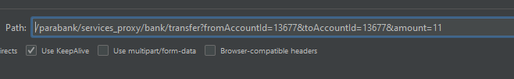

Similarly, the account number is also hardcoded in the path for transferring funds and finding transactions. The method to acquire this account number is simpler as this account number can be obtained in the account overview.

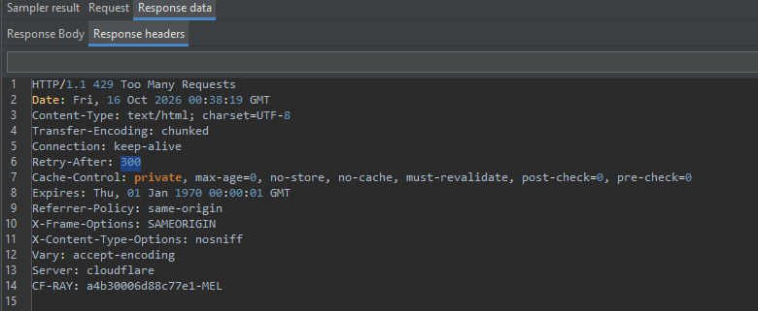
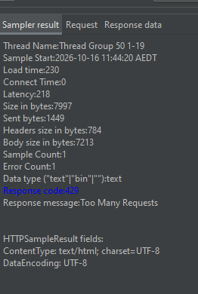

During initial test runs, a significant (>80% error%) request failure was observed for thread group with 10 users or more. This was determined to be due to rate limiting features of the Parabank website preventing an IP address from sending a large number of requests with response code 429 observed in the sampler result in the results tree. The retry after line in response header shows a count of 300 seconds meaning after the first 429 error, any HTTP request from the IP address is blocked for 5 minutes.
In the interest of writing this report, the test plan implements timer delay before each HTTP request to combat this rate limit in the website. Simple requests such as clicking and redirecting used a 1-2 seconds timer while requests which includes filling an input field such as log in and transferring funds used 1-3 seconds timer to mimic the delay of a human user. This fully prevented code 429 in the 10 user group but did not fully prevent code 429 in the 20 and 50 user groups. However, due to the test duration being 20 seconds, it was decided that increasing the delay further would hinder test runs especially for the 1 and 10 user group.

Most of the clicking and redirecting requests does not contain many useful response data therefore assertions for these requests will be simply asserting response code 200 for successful requests.

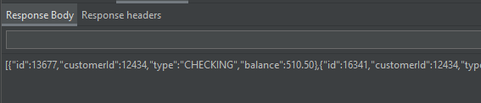

For account overview and account detail request, the response body contains information such as account number, customerId, type of account, and balance. For this request a text response assertion matching pattern that contains “balance”, “customerId”, and “id” is used on top of response code 200. The specific balance and ID values are determined to be unusable since they change for every transactions and for every account.

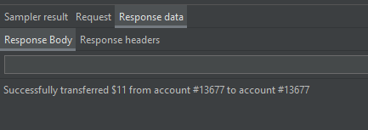

Response body for transferring 11 dollars are shown in the image above. Therefore the text response assertion used for this request includes matching pattern substring “Successfully transferred $11”. Substring is used instead of contains as the $ symbol was determined to hinder the contains pattern matching.

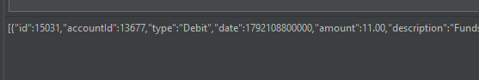

Lastly, finding transactions by amount 11 dollars contain the response body which has the line “amount”:11.00 which changes depending on what amount the search is used with. As the test always uses 11 dollars to search the text response for this request will be pattern matching that contains “amount”:11. Other HTTP requests that were not mentioned having text response assertion uses a simple response code 200 assertion instead.

Results and Analysis

The performance testing was done using four thread groups configured with 1, 10, 20, and 50 users each with 10 second ramp up period and 20 second duration. The results were collected using JMeter Aggregate Report listener. With summarised overall findings as follows:
Metric | 1 user | 10 users | 20 users | 50 users
Total Samples | 12 | 88 | 168 | 433
Throughput (requests/sec) | 0.66 | 4.4 | 8.6 | 22
Average Response Time (ms) | 253 | 247 | 141 | 53
Minimum Response Time (ms) | 193 | 189 | 8 | 6
Maximum Response Time (ms) | 447 | 488 | 673 | 691
95th Percentile (ms) | 414 | 427 | 422 | 318
Error % | 0.00% | 0.00% | 47.02% | 85.22%
Table 1. Summary of Aggregate Reports from all request from the 4 thread group
Metric | 1 User | 10 Users | 20 Users | 50 Users
Home Page
Samples | 2 | 11 | 22 | 58
Throughput (req/sec) | 0.11 | 0.62 | 1.1 | 3
Average (ms) | 206 | 217 | 200 | 144
Min (ms) | 197 | 191 | 9 | 8
Max (ms) | 215 | 242 | 354 | 691
95th Percentile (ms) | 215 | 236 | 228 | 318
Error % | 0.00% | 0.00% | 9.09% | 44.83%
Login
Samples | 1 | 10 | 20 | 50
Throughput (req/sec) | 2.4 | 1 | 1.9 | 4.9
Average (ms) | 414 | 418 | 433 | 177
Min (ms) | 414 | 408 | 271 | 8
Max (ms) | 414 | 430 | 673 | 536
95th Percentile (ms) | 414 | 427 | 562 | 436
Error % | 0.00% | 0.00% | 5.00% | 62.00%
Table 2. Summary of Aggregate Reports for Homepage and Login request from the 4 thread group

*Raw aggregate report tables are shown in the appendix

Based on Table 1, The throughput increased consistently as the number of concurrent users increased. The 1 user Thread Group recorded approximately 0.66 requests per second, increasing to 4.4 requests per second for 10 users, 8.6 for 20 users, and 22 for 50 users. This indicates that more HTTP requests were completed as the number of concurrent users increased. However, throughput measures both successful and unsuccessful requests. Therefore, the higher throughput observed in the 20 and 50 user Thread Groups does not necessarily indicate that the website successfully processed more user operations.
The 1 and 10 user Thread Groups demonstrated relatively stable performance with no recorded errors. The average response time decreased slightly from 253 ms to 247 ms, while the maximum response time increased from 447 ms to 488 ms. The 95th percentile response time also remained relatively consistent at 414 ms and 427 ms respectively. This indicates that increasing the number of concurrent users from 1 to 10 did not significantly affect the response times or reliability of the tested requests.
However, a noticeable change was observed in the 20 and50 user Thread Groups. The error percentage increased significantly to 47.02% and 85.22% respectively. Despite this, the average response time decreased to 141 ms for 20 users and 53 ms for 50 users. This reduction is not associated with improved performance, as many requests were unsuccessful due to HTTP 429 responses. These responses may be rejected quickly without completing the intended operation, reducing the recorded minimum and consequently average response time.
Table 2 provides additional insights to this observation as Table 2 compiles results only for homepage and login request in which most of the requests were successful for the 20 user Thread Groups as these were the first 2 requests to be performed by any user. Table 2 shows that for the homepage request, the average response time remained relatively consistent across the first three workloads, at 206 ms, 217 ms, and 200 ms respectively. The error percentage remained at 0% for the 1 and 10 user groups before increasing to 9.09% at 20 users and 44.83% at 50 users. The maximum response time also increased slightly to 354 at 20 user groups and significantly to 691 ms at 50 users implying some requests took longer to process at these higher workloads.
Similarly, the login request recorded average response times of 414 ms, 418 ms, and 433 ms for 1, 10, and 20 users respectively. The error percentage remained at 0% for the first two workloads and increased only slightly to 5% at 20 users. However, the 95th percentile response time increased to 562 ms at 20 users compared with 427 ms at 10 users as well as the maximum response time increasing from 430 ms to 673 ms for 20 users suggesting that some login requests experienced longer response times.
The most significant issue observed during testing was the increase in error percentage at higher user loads. Both the 1 and 10 user groups recorded 0% errors, whereas the 20 user group recorded 47.02% and the 50 user group recorded 85.22%.
As discussed earlier in test design, HTTP 429 (Too Many Requests) responses were observed during testing. These responses indicate that the server or an associated protection mechanism was limiting incoming requests. The response headers also included a retry after value of 300 seconds, indicating that the client should wait 5 minutes before attempting another request. Due to this rate limiting feature, later requests in the 20 and 50 user groups were significantly affected by the 429 error response code although few initial requests, especially some of the homepage and login request, could be performed successfully.
While these results demonstrate that the public ParaBank website became increasingly unreliable under the tested workloads, this is only true for concurrent users that are sourced from the same IP address, it is likely this rate limiting feature could be addressed by setting up virtual users with varying IP address.

Conclusion
Overall, the performance testing demonstrated that ParaBank handled the 1 and 10 user workloads with relatively stable response times and no recorded errors. However, increasing concurrency to 20 and 50 users resulted in significant increases in request failures, reaching 47.02% and 85.22% respectively heavily due to rate limiting feature which was indicated by HTTP 429 responses. Additionally, a 20 seconds test duration limit including a 10 ramp up period limits the findings to the relatively short duration performance testing. Further testing using a controlled environment without rate limiting restrictions or set up with virtual users having varying IP address to attempt to workaround the rate limiting restrictions may be useful in further assessing the application’s performance more accurately.

Appendix

1 User aggregate report

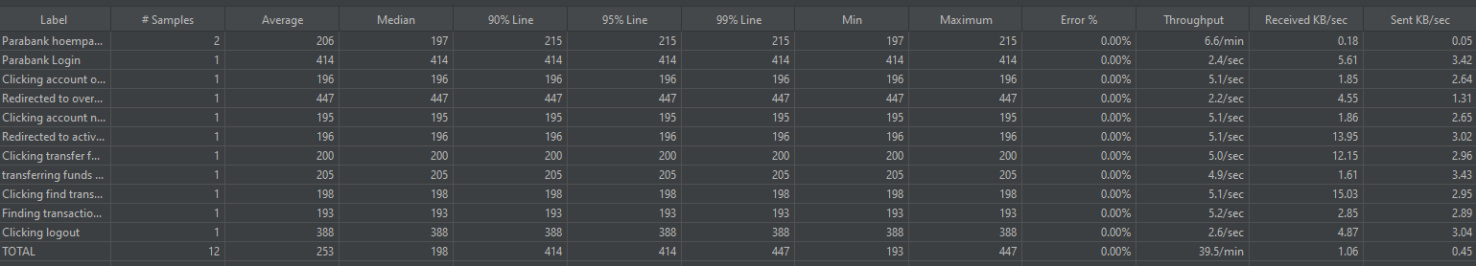

10 User aggregate report

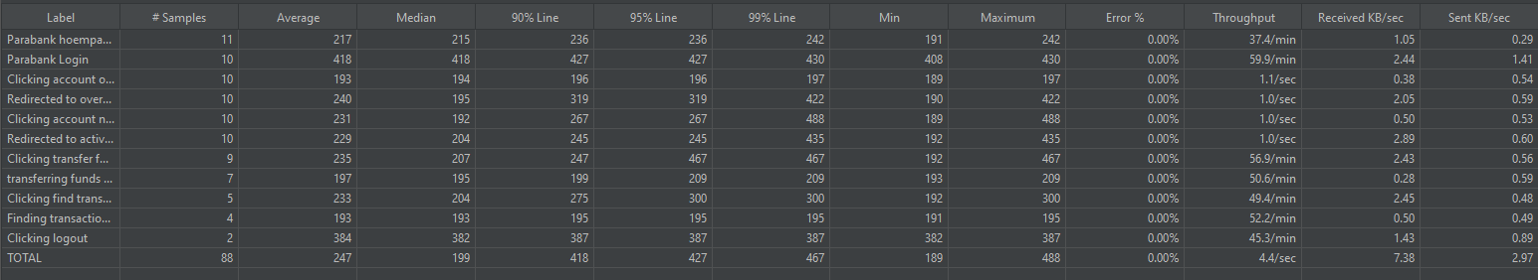

20 User aggregate report

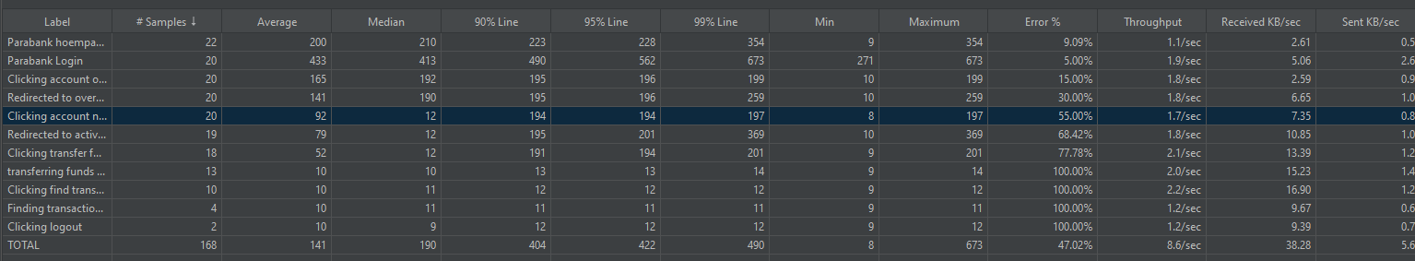

50 User aggregate report

